Hello,
Below is a suggested 20-30 minute lesson about the Armor of God for you and your child to do together!

✓ Prayer:
o Prayer requests: What are they struggling with? Is someone they know struggling with something that we can pray for? Is the world struggling with something that we can pray for?
o Praises: What has God done in their lives that they are thankful for?

✓ Bible Reading:
- Ephesians 6:10-20 – The Armor of God
¹⁰ Finally, be strong in the Lord and in his mighty power. ¹¹ Put on the full armor of God, so that you can take your stand against the devil’s schemes. ¹² For our struggle is not against flesh and blood, but against the rulers, against the authorities, against the powers of this dark world and against the spiritual forces of evil in the heavenly realms. ¹³ Therefore put on the full armor of God, so that when the day of evil comes, you may be able to stand your ground, and after you have done everything, to stand. ¹⁴ Stand firm then, with the belt of truth buckled around your waist, with the breastplate of righteousness in place, ¹⁵ and with your feet fitted with the readiness that comes from the gospel of peace. ¹⁶ In addition to all this, take up the shield of faith, with which you can extinguish all the flaming arrows of the evil one. ¹⁷ Take the helmet of salvation and the sword of the Spirit, which is the word of God.
¹⁸ And pray in the Spirit on all occasions with all kinds of prayers and requests. With this in mind, be alert and always keep on praying for all the Lord’s people. ¹⁹ Pray also for me, that whenever I speak, words may be given me so that I will fearlessly make known the mystery of the gospel, ²⁰ for which I am an ambassador in chains. Pray that I may declare it fearlessly, as I should.

✓ Video:
O The Armor of God Song
- The Armor of God

✓ Memory Verse:
o Encourage children to remember the below verse that is related to the lesson:
- The LORD is my light and my salvation; Whom shall I fear? The LORD is the strength of my life; Of whom shall I be afraid? Psalm 27:1
✓ Craft:
- Armor of God Activity:
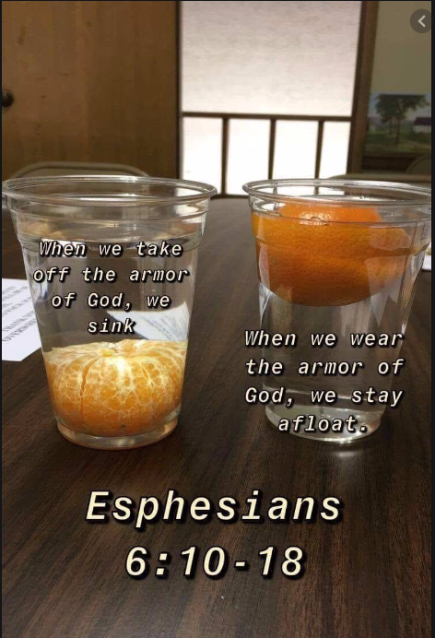

- Armor of God Coloring:
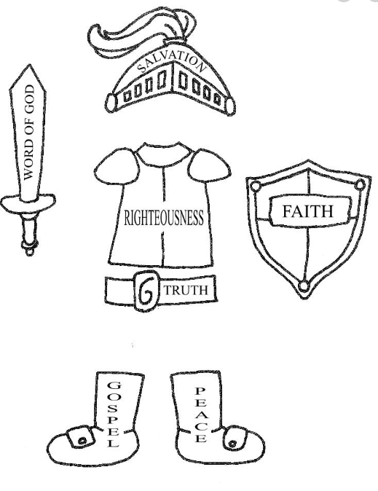

✓ Share:
o Share your lesson and craft with friends, family, and me (Ms.Whitney @ 775-622-6272)!

Remember, you are so loved.
Blessings,
Whitney

