Hello,
Below is a suggested 20-30 minute lesson reminding us not to worry for you and your child to do together!

✓ Prayer:
o Prayer requests: What are they struggling with? Is someone they know struggling with something that we can pray for? Is the world struggling with something that we can pray for?
o Praises: What has God done in their lives that they are thankful for?

✓ Bible Reading:
- Matthew 6:25-34
²⁵ “I tell you this: Do not worry about your life. Do not worry about what you are going to eat and drink. Do not worry about what you are going to wear. Is not life more important than food? Is not the body more important than clothes? ²⁶ Look at the birds in the sky. They do not plant seeds. They do not gather grain. They do not put grain into a building to keep. Yet your Father in heaven feeds them! Are you not more important than the birds? ²⁷ Which of you can make himself a little taller by worrying? ²⁸ Why should you worry about clothes? Think how the flowers grow. They do not work or make cloth. ²⁹ But I tell you that Solomon in all his greatness was not dressed as well as one of these flowers. ³⁰ God clothes the grass of the field. It lives today and is burned in the stove tomorrow. How much more will He give you clothes? You have so little faith! ³¹ Do not worry. Do not keep saying, ‘What will we eat?’ or, ‘What will we drink?’ or, ‘What will we wear?’ ³² The people who do not know God are looking for all these things. Your Father in heaven knows you need all these things. ³³ First of all, look for the holy nation of God. Be right with Him. All these other things will be given to you also. ³⁴ Do not worry about tomorrow. Tomorrow will have its own worries. The troubles we have in a day are enough for one day.

✓ Video:
O Do not worry

✓ Memory Verse:
o Encourage children to remember the below verse that is related to the lesson:
- Don’t worry about tomorrow, because tomorrow will worry about itself. Each day has enough trouble of its own. Matthew 6:34

✓ Craft: Do not worry coloring page

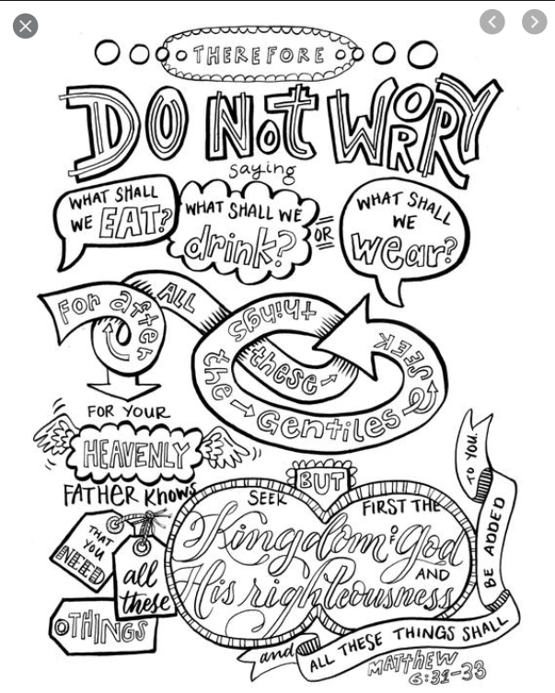

✓ Share:
o Share your lesson and craft with friends, family, and me (Ms.Whitney @ 775-622-6272)!

